**19CSE19281**

**DIGITAL CIRCUITS AND SYSTEMS**

**LAB PROJECT**

**GROUP - J**

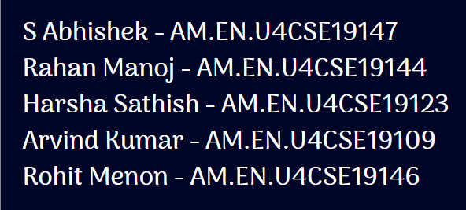

**DESIGN A MEALY FSM DETECTOR FOR THE SEQUENCE 111101 AND IMPLEMENT USING TINKER CAD**

**STATE DIAGRAM**

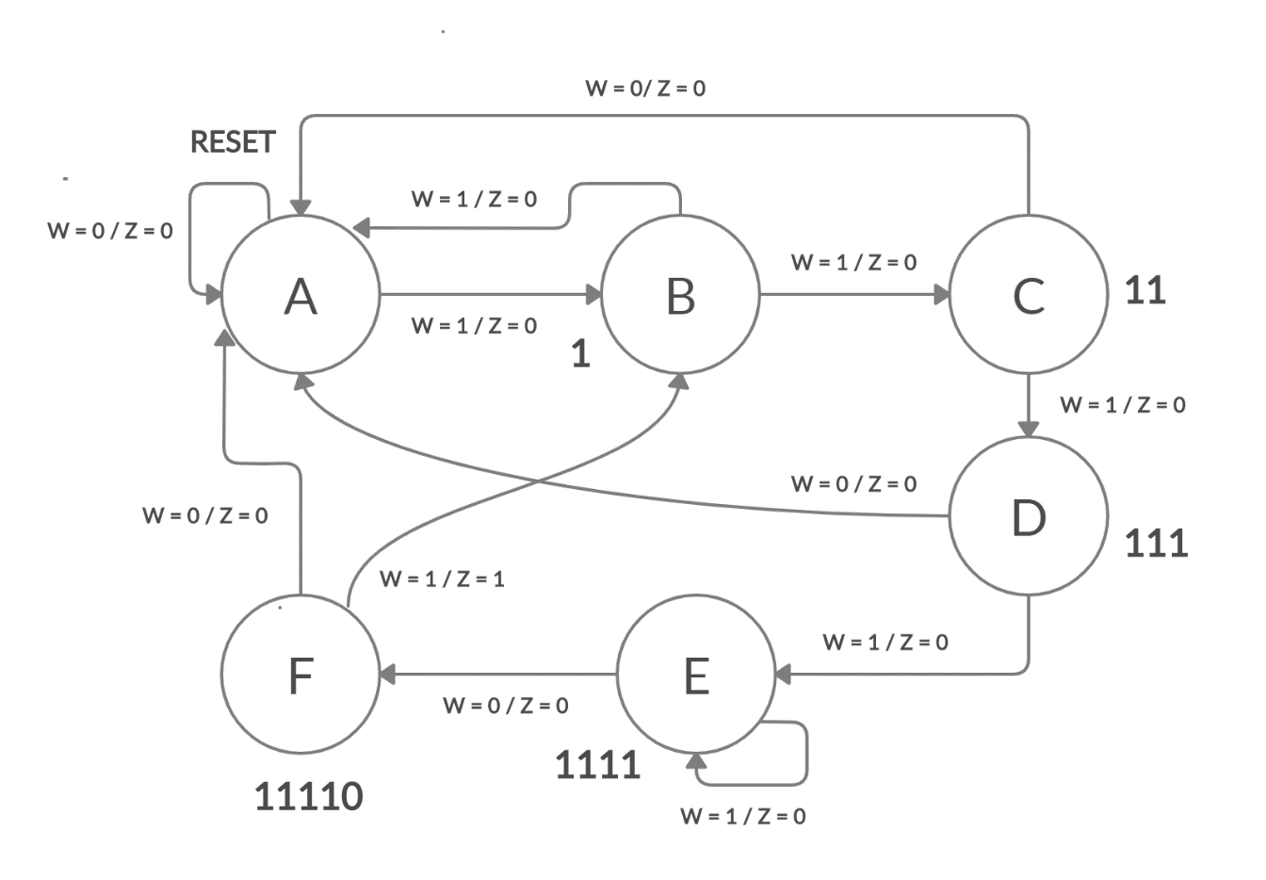

**STATE TABLE**

|  |  |  |  |  |
| --- | --- | --- | --- | --- |
|  | **NEXT STATE** | | **OUTPUT** | |
| **W = 0** | **W = 1** | **W = 0** | **W = 1** |
| **A** | A | B | 0 | 0 |
| **B** | A | C | 0 | 0 |
| **C** | A | D | 0 | 0 |
| **D** | A | E | 0 | 0 |
| **E** | F | E | 0 | 0 |
| **F** | A | B | 0 | 1 |

**STATE ASSIGNED TABLE**

|  |  |  |  |  |  |  |  |  |  |  |  |  |
| --- | --- | --- | --- | --- | --- | --- | --- | --- | --- | --- | --- | --- |
|  | PRESENT STATE | | | NEXT STATE | | | | | | OUTPUT | | |
| W = 0 | | | W =1 | | | W = 0 | W = 1 | |
| Y3 | Y2 | Y1 | Y3 | Y2 | Y1 | Y3 | Y2 | Y1 | Z | Z |
| A | 0 | 0 | 0 | 0 | 0 | 0 | 0 | 0 | 1 | 0 | 0 |
| B | 0 | 0 | 1 | 0 | 0 | 0 | 0 | 1 | 0 | 0 | 0 |
| C | 0 | 1 | 0 | 0 | 0 | 0 | 0 | 1 | 1 | 0 | 0 |
| D | 0 | 1 | 1 | 0 | 0 | 0 | 1 | 0 | 0 | 0 | 0 |
| E | 1 | 0 | 0 | 1 | 0 | 1 | 1 | 0 | 0 | 0 | 0 |
| F | 1 | 0 | 1 | 0 | 0 | 0 | 0 | 0 | 1 | 0 | 1 |

**KMAP FOR Y1**

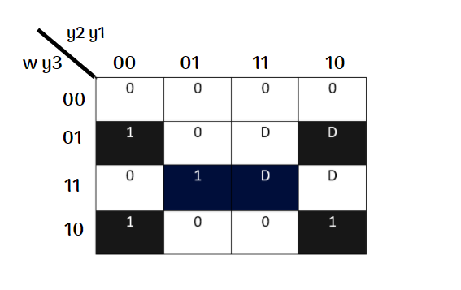

Y1 = w’ y3 y1’ + y1 w y3 + y1’ w y3’

**KMAP FOR Y2**

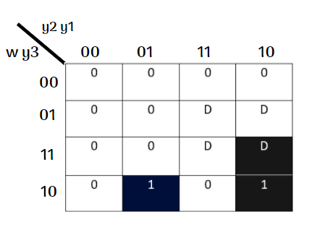

Y2 = y1 y2’ y3’ w + w y2 y1’

**KMAP FOR Y3**

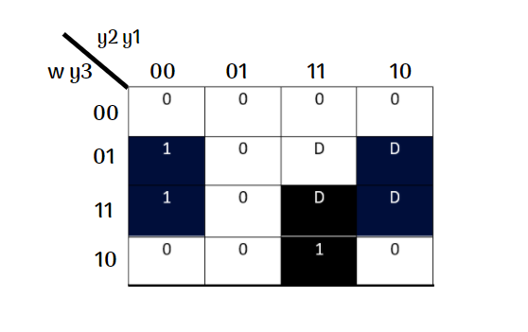

Y3 = y1’ y3 + w y1 y2

**KMAP FOR Z**

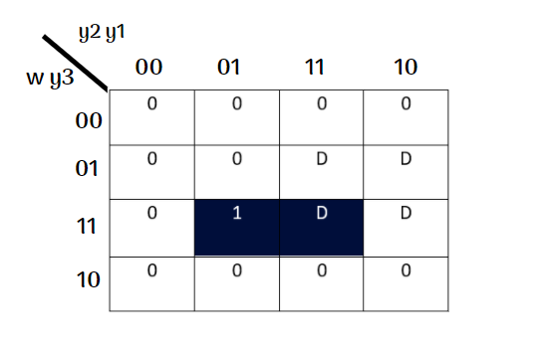

Z = w y3 y1

**CIRCUIT**

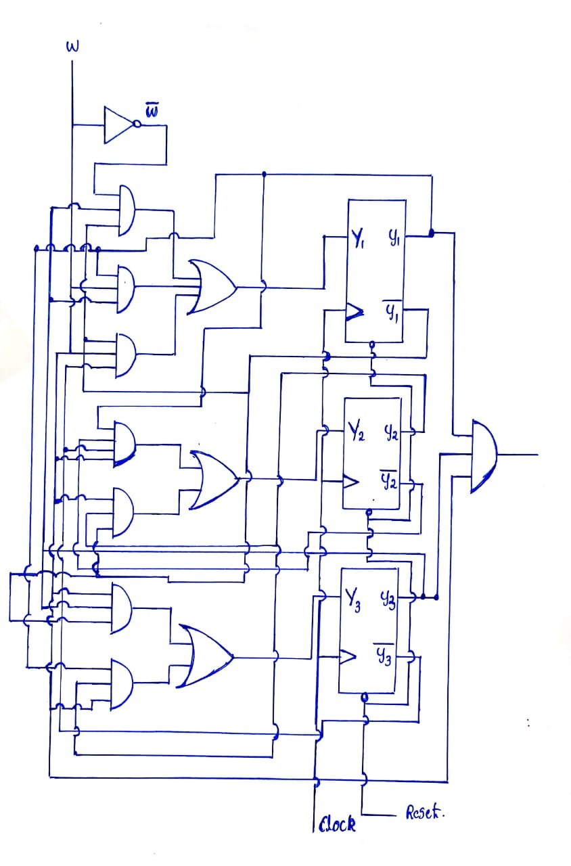

**TINKER CAD IMPLEMENTATION**

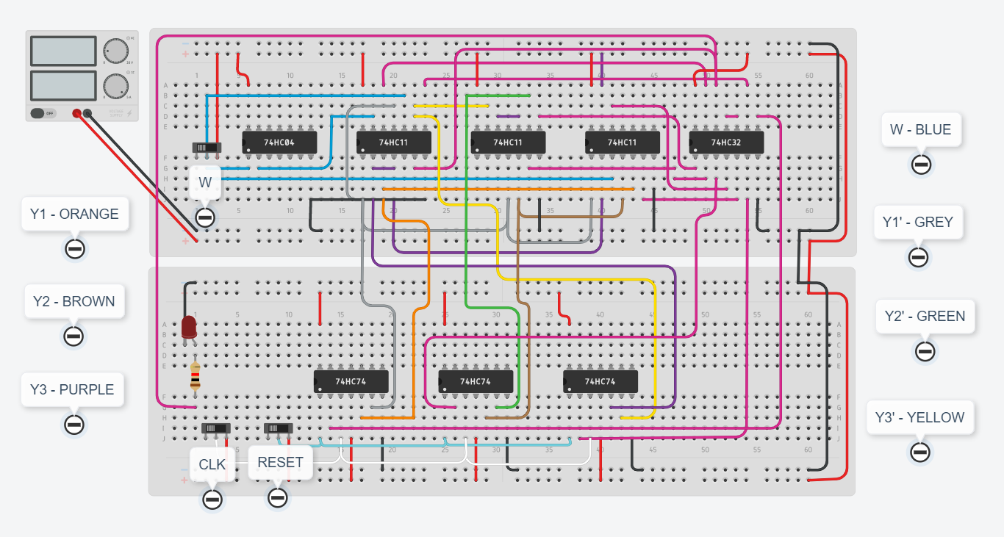

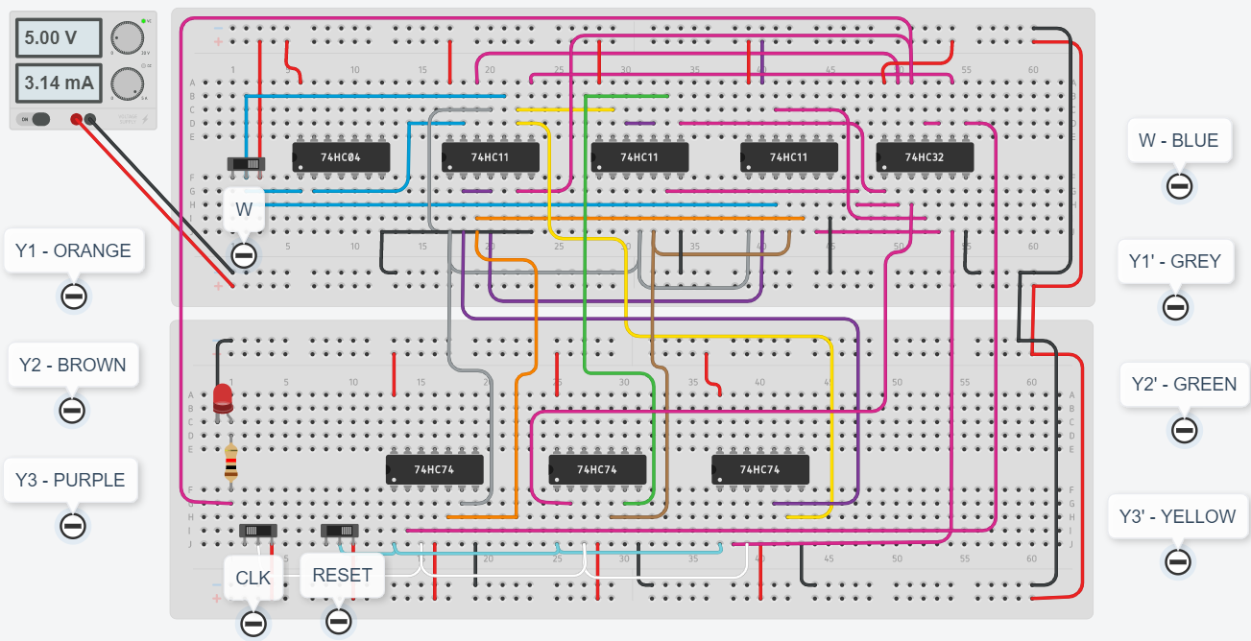

**RESULT**

* The logic circuit was implemented in accordance with the theory and output was obtained successfully by the glow of LED.